Report on lab 7. Litvin Saveli

Github:

# Create and populate Dimension of TIME DW – Layer

Physical Diagram:

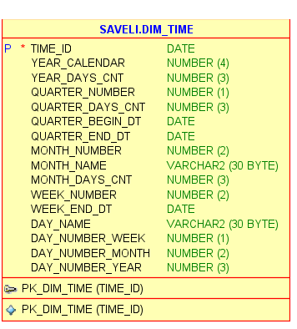

Script: Link on github bellow title

Final DW.TIME Layer:

